Linux Management Users and groups
Exercises about users and groups management
NOTE 1: We have to start a root session to do the exercises
NOTE 2: Take into account that user and group names are CASE SENSITIVE
1. Add two new groups named “daw” and “crey”
2. Change “daw” and “crey” GIDS to 2001 and 2002, respectively.
3. Create a new group called “profesores” with GID of 2000. Then, modify the group name to teachers
4. Verify that you have correctly created the groups named “daw”, “crey” and “teachers”.

5. Add a new user named “john” whose primary group is “crey”. Has the home directory been created with the default command?
6. Add a new user named “mary”, whose primary group is “daw” and the home directory /home/mary
7. Add a new user named “martha”, whose primary group is “teachers”, the home directory
/home/martha and belonging to the secondary group “crey”
8. Add the following names to the users that you have just created:
a. John= “John Doe”
b. Mary = “Mary Williams”
c. Martha = “Martha Jones”
9. How could you check that you have created all the users with the right primary groups?
cat /etc/passwd (here you can view the primary groups of each user)




10. Verify if crey and daw groups have martha as a member
11. Can you log in with any of the users you have created?
No, you can´t login until you set a password.
12. Set the password “martha22” for the user “martha”

13. Display on the shell prompt the groups to which Martha belongs
14. Create a directory named “teachers” in “/home”. Then, assign the directory “/home/teachers” to
the user martha (you can do all the steps typing just one command).
logi
15. Now, log in as user “martha”. Run the command “cd $SHOME” and check that the home directory is “/home/teachers”
login as martha then : pwd

16. Go back to the root shell
exit
17. Change the shell of the user named “john” to “sh”
18. Add the user “martha” to the secondary group “daw” without removing the already assigned
secondary groups.
19. Run a command to print the following information for each user
User | Primary group | Secondary groups
john | crey | crey
mary | daw | daw
martha | teachers | crey, daw

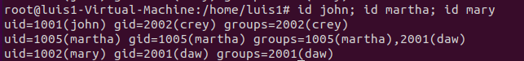

20. Delete all the groups you have created. Could you delete them? Why?
No, you cant delete the groups because they are the primary groups of just one user

21. Delete all the users you have created, including the files and directories inside the home.
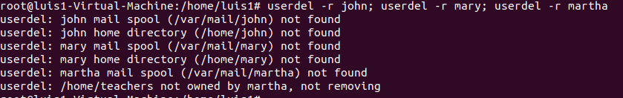
22. Try again to delete the groups

